BRAINSTORM & IDEA PRIORITIZATION

Date | 31 OCTOBER 2025
Team ID | NM2025TMID04251
Project Name | CRM Application for Jewel Management-(Developer) in Salesforce
Maximum Marks | 4 Marks

This guided project focuses on the creation of a CRM Application for Jewel Management using Salesforce. The system is designed to automate jewelry business operations such as customer management, item tracking, pricing, and billing through Salesforce’s declarative tools like Object Manager, App Builder, and Flow Builder. This solution eliminates manual errors, enhances data accuracy, and provides real-time visibility through dashboards and reports. The process includes collaboration, brainstorming of ideas, grouping them into meaningful modules, and prioritizing development to ensure an efficient workflow for business management.

Step-1: Team Gathering, Collaboration and Select the Problem Statement:
Team Collaboration:
The CRM Application for Jewel Management is developed by a team with clearly defined roles:
Project Manager – Oversees project planning, timeline, and quality of deliverables.
Business Analyst – Interacts with jewelry shop owners to gather and document business requirements.
Salesforce Admin – Designs objects, fields, page layouts, and automations using Salesforce setup.
Salesforce Developer – Implements custom logic using Apex triggers, classes, and flows.
Tester (QA) – Tests all modules to ensure smooth functioning and no logical or data errors.
Simple Team Workflow:
1. Business Analyst collects jewelry business requirements.
2. Admin and Developer build CRM modules like Customer, Item, Price, and Billing.
3. Tester validates workflows, billing automation, and reporting.
4. Project Manager reviews and delivers the project for evaluation.

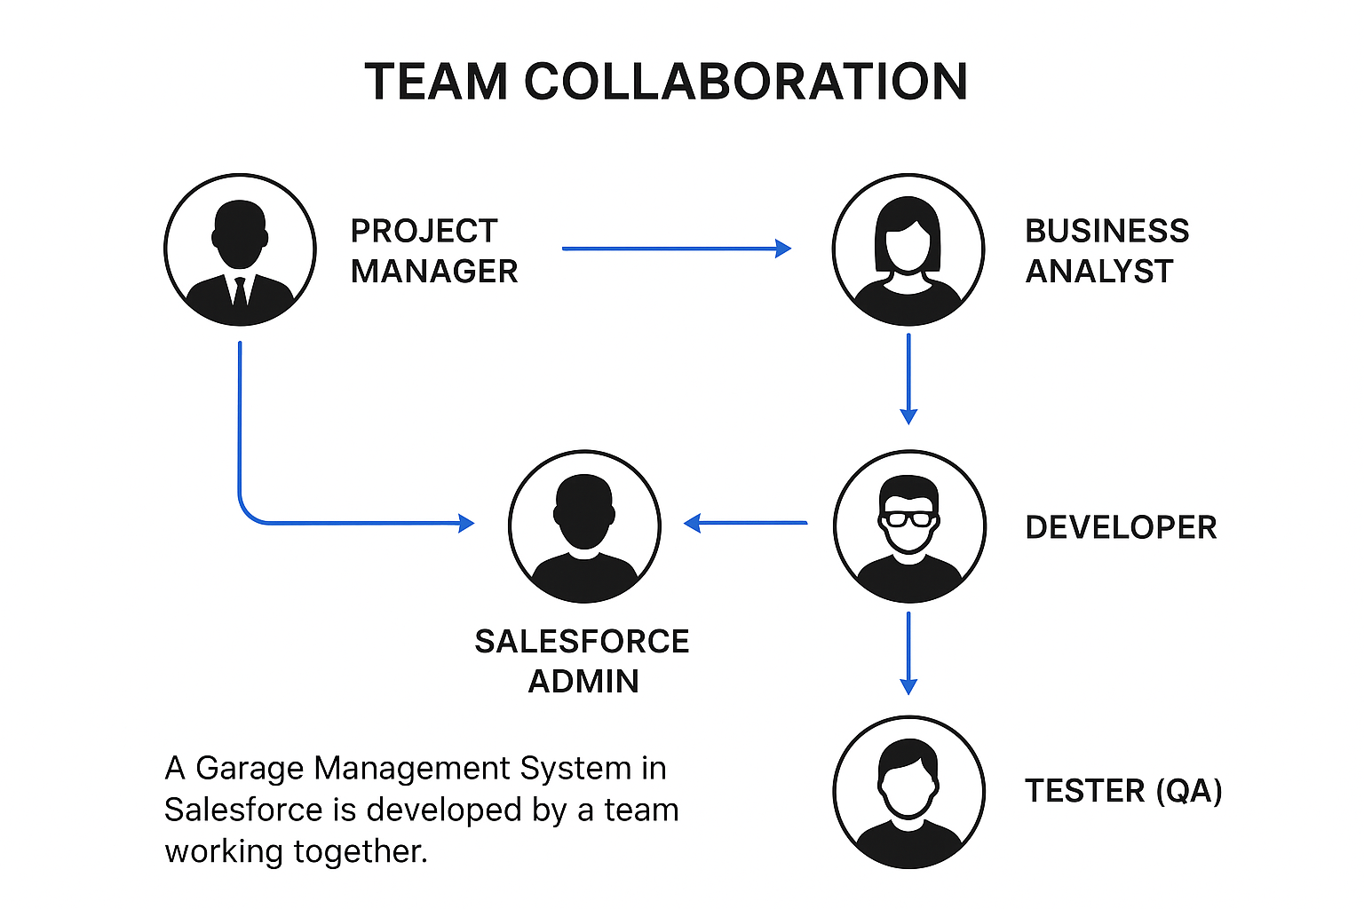

Step-2: Brainstorm, Idea Listing and Grouping:
The CRM Application for Jewel Management addresses challenges faced by jewelry stores such as manual billing, pricing errors, customer data mismanagement, and lack of automation. Through brainstorming, the following ideas were generated and organized into modules for better structure:
1. Setup & Configuration Module – Object creation, tabs, fields, record types, and page layouts.
2. Security & Access Control Module – Profiles, roles, permission sets, and user creation.
3. Reporting & Analytics Module – Reports and dashboards for business insights.
4. Automation & Process Module – Record-triggered flows for billing and pricing updates.
5. User Management & Adoption Module – User tracking and engagement reports.
These modules ensure end-to-end automation and efficient jewelry management using Salesforce cloud capabilities.

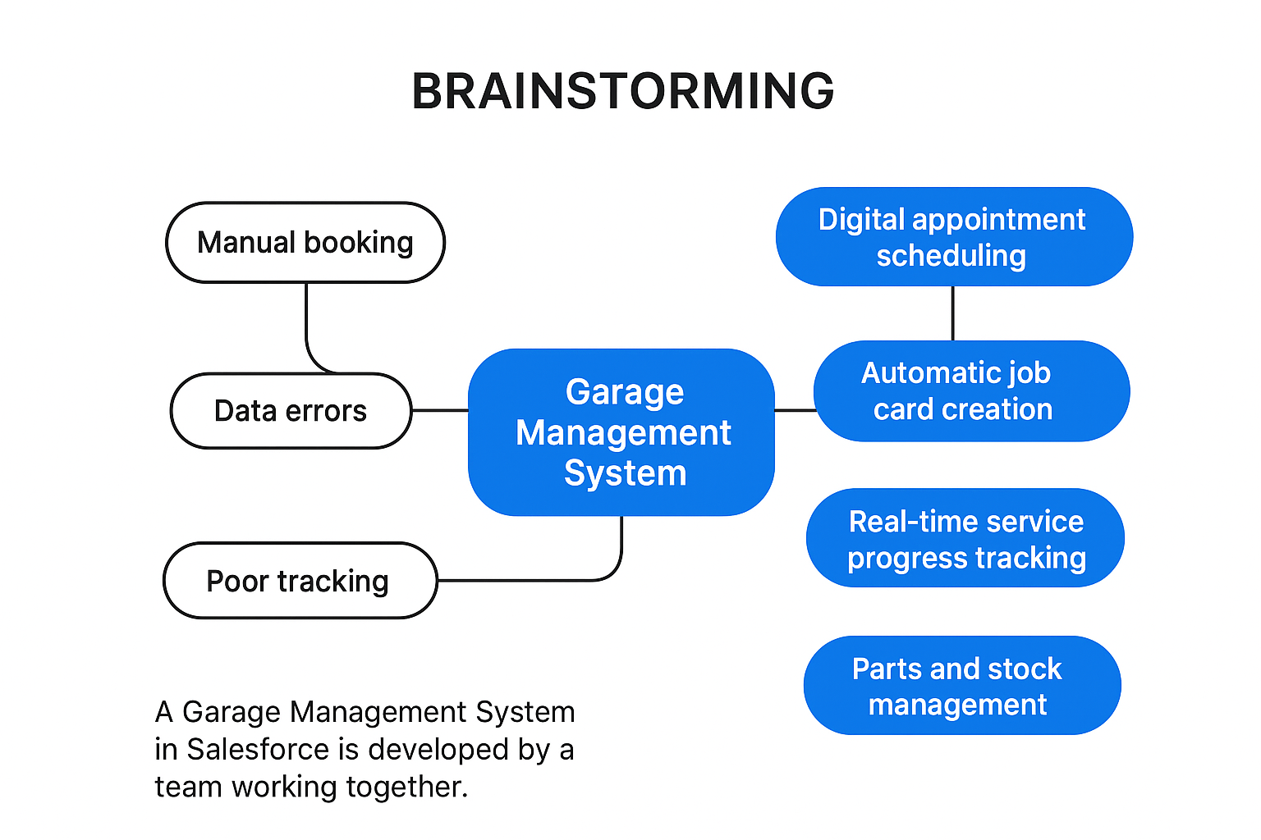

Step-3: Idea Prioritization:
Final Summary:
In the CRM Application for Jewel Management, development should start with the foundational modules that support daily business operations — Customer, Item, Price, and Billing objects — as they form the core structure of the application. Once these core modules are functional, automation processes like record-triggered flows and validation rules should be added to ensure data consistency and efficiency. Next, security modules involving roles, profiles, and permission sets should be implemented to protect business data. Finally, dashboards, reports, and user adoption tracking can be developed to provide management insights and ensure better decision-making and user engagement.

